**INSTALLER PACKAGING**

muRataStudioSetup in the Solution Explorer is the installer packaging project

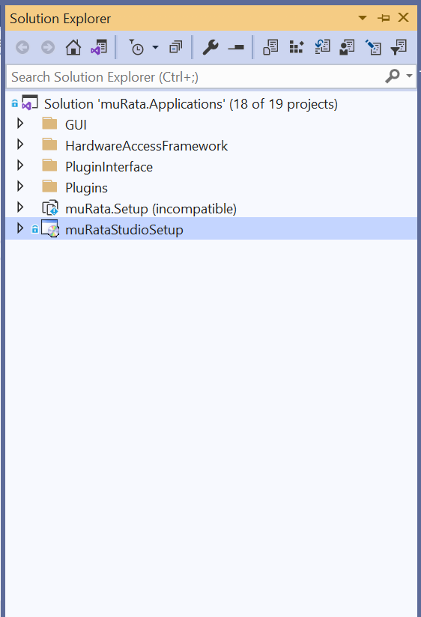

1) Build the solution in Release mode by removing the existing command line arguments in case if any exists.

1. Copy the .adz file in [...muratastudio\Apps\muRata\bin\Debug\Devices] to [...muratastudio\Apps\muRata\bin\Release\Devices].
2. Also make sure to confirm , we have same .adz file in all the below three locations.

* [...\muratastudio\Apps\muRata\Devices]
* [...muratastudio\Apps\muRata\bin\Debug\Devices]
* [...muratastudio\Apps\muRata\bin\Release\Devices].

1. Please make sure to confirm for Plugins also

[...\muratastudio\Apps\muRata\Devices]

[...muratastudio\Apps\muRata\bin\Debug\Plugins]

[...muratastudio\Apps\muRata\bin\Release\Plugins]

2) After successfully Release build , select the file system editor

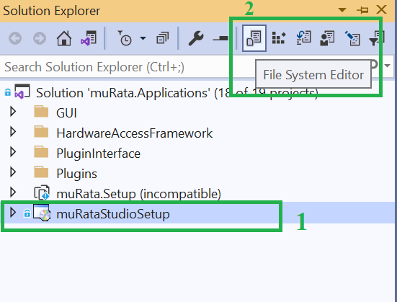

3) Following are the existing folders in the FileSystem Editor – Application Folder, User’s Desktop, User’s Program Menu.

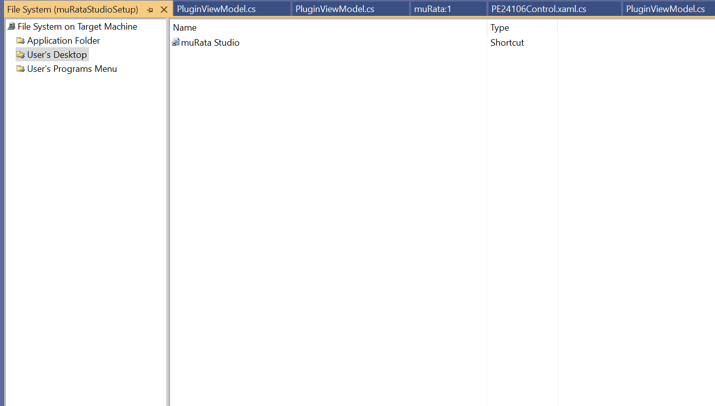

4) Select the Application Folder

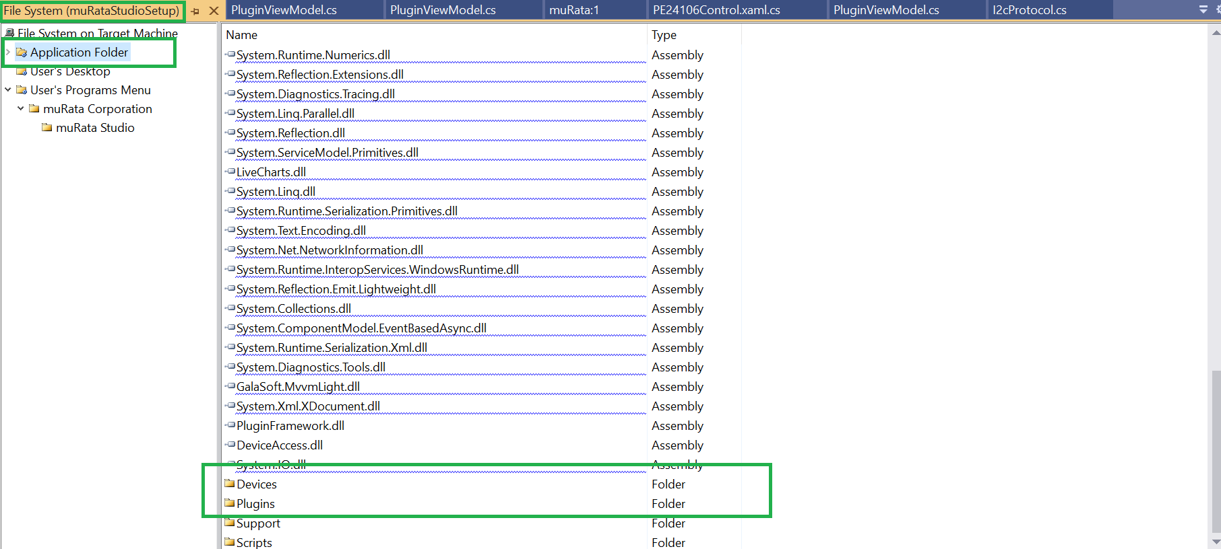

5) Each time we build an msi, Device and Plugin Folder inside the Application folder should be reloaded.

6) For that, select the Device Folder.

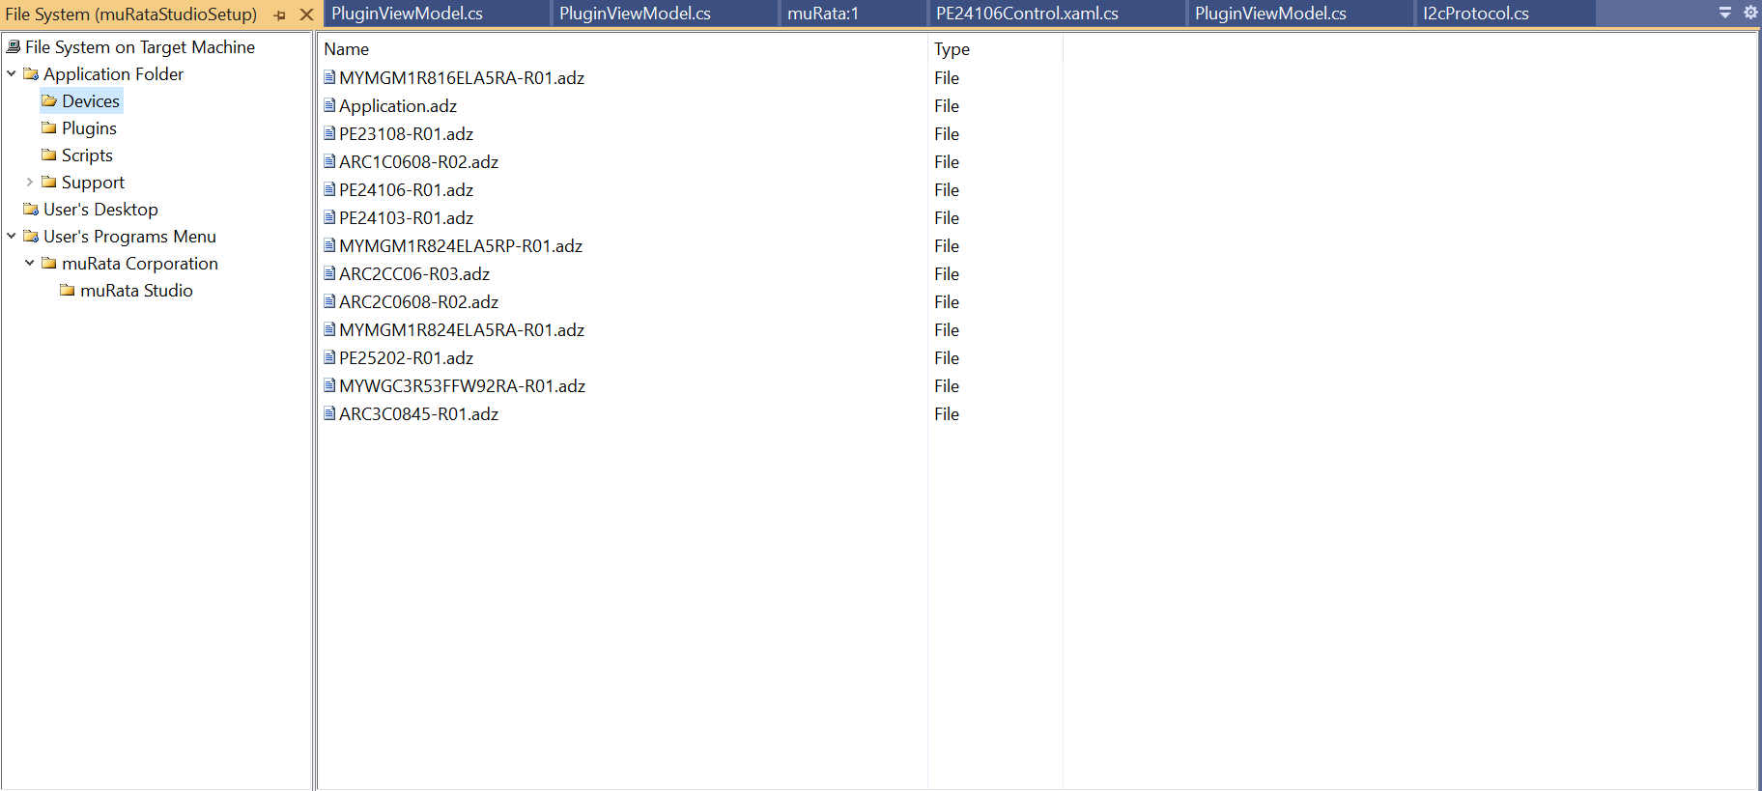

7) Delete all the existing .adz file in Device Folder.

8) After deleting, Right click File – >Add - >File

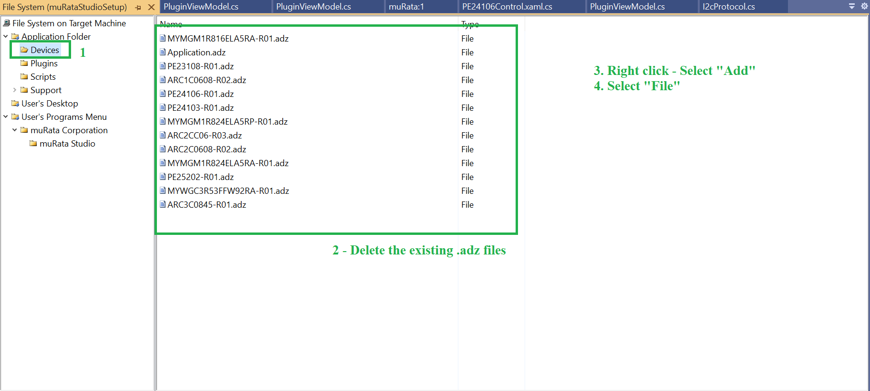

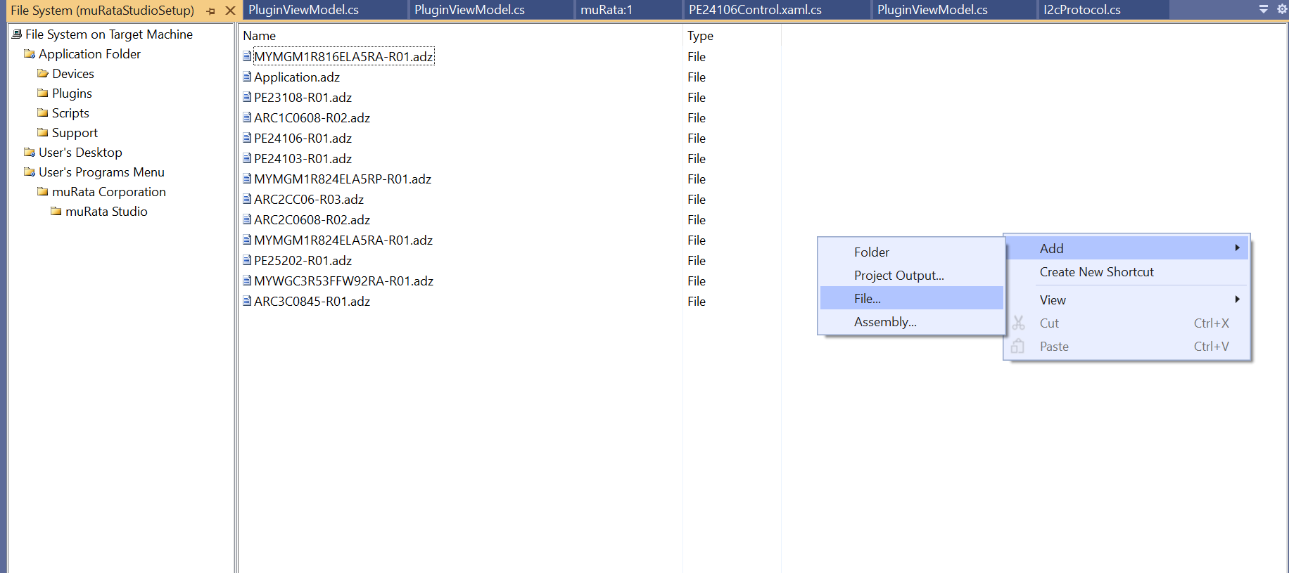9) A new Dialog window will be opened, from which we have to load the updated .adz files by selecting All and “Open”.

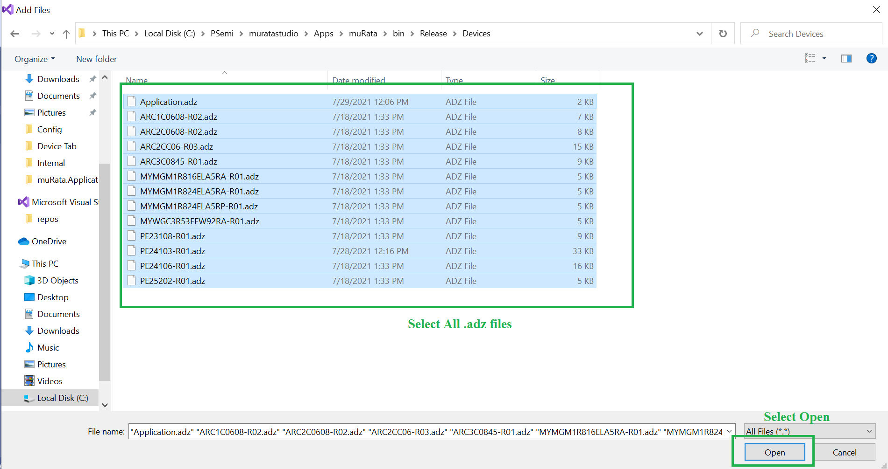

10) Click “Open”. This will update the .adz file in Device folder of file system editor.

Similarly do this for Plugins folder also.

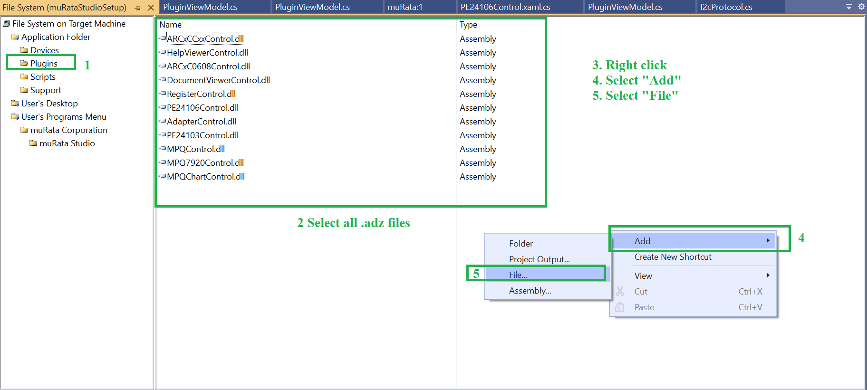

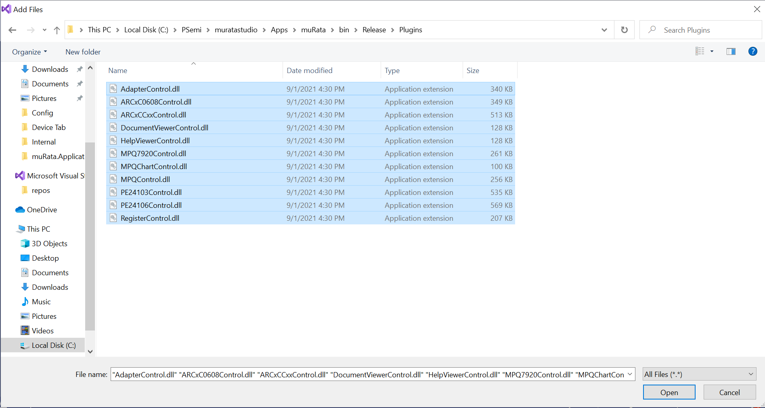

1. Click “Open”. This will update the .dll of Plugins in Plugins folder of file system editor.
2. Now inorder to update the .dll (DeviceAccess.dll,..etc.) we have to add Project Output and then we have to select Murata as primary output and select configuration as active when it is in release environment, incase if it is in debug environment then do change the configuration to release. Then click OK, so .dll will gets updated.

And Once Primary output is updated we have to create shortcut, for that in File System Editor-> Users Desktop -> Create a shortcut from Primary Output. (follow as in below image )

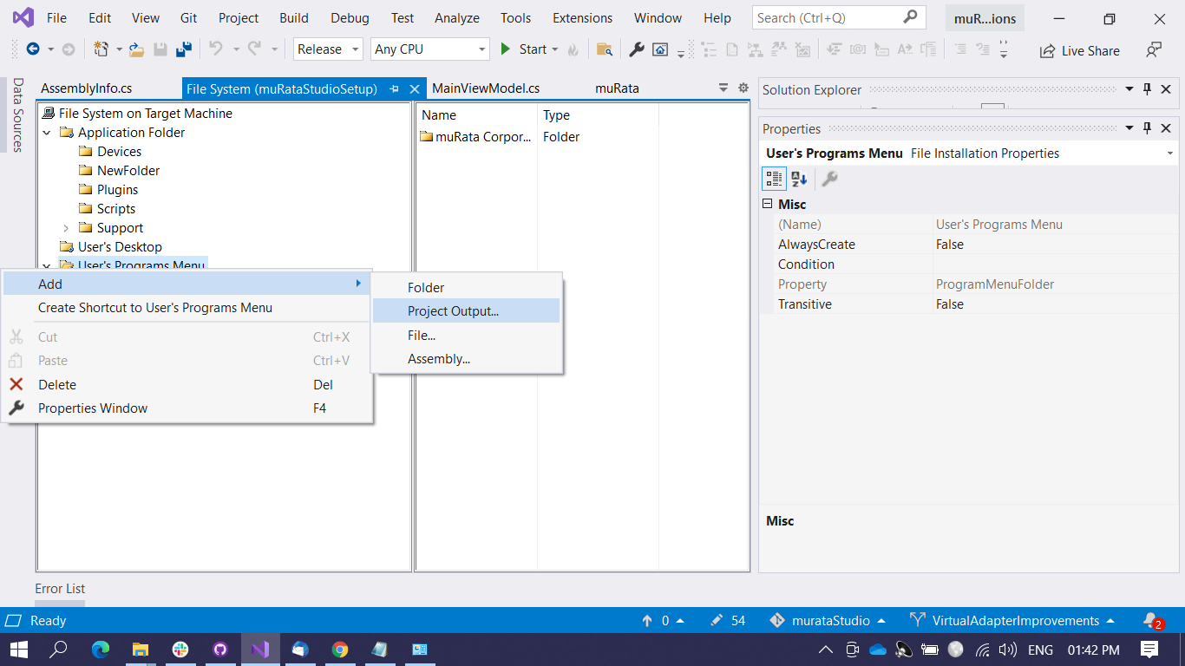And also create a shortcut inside muratastudio as well.(follow as in below image)

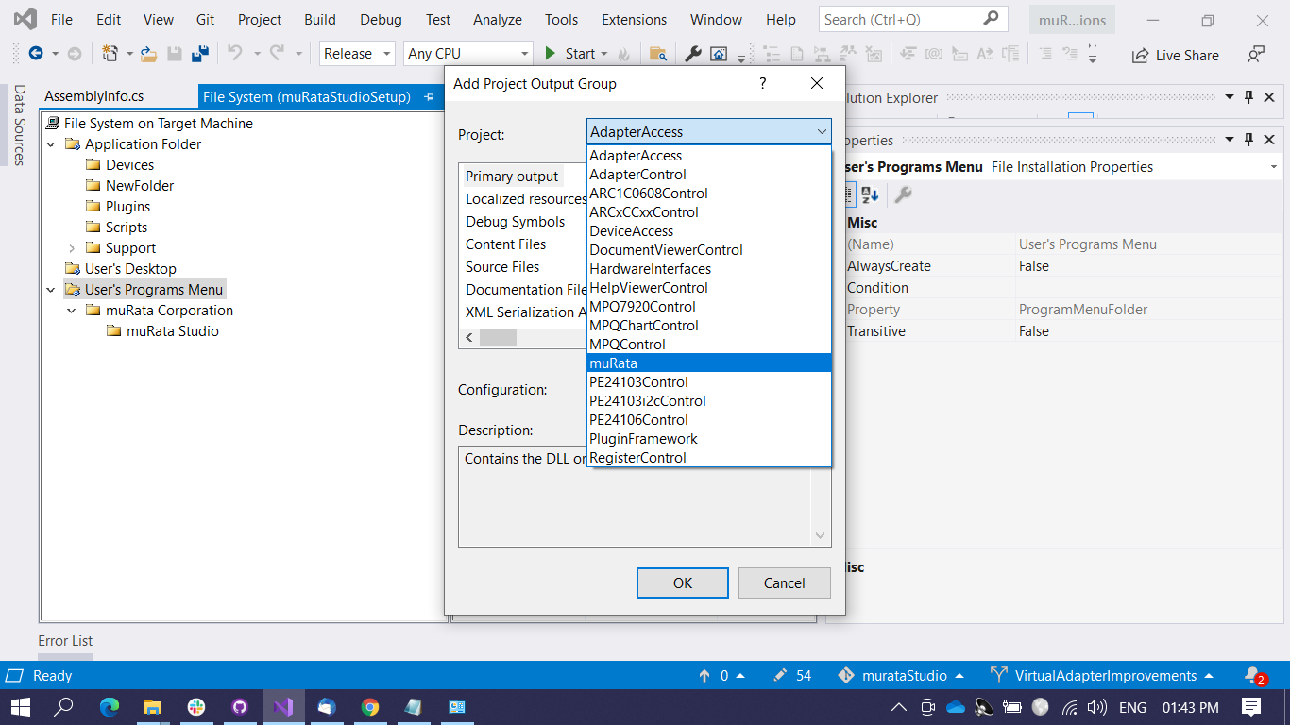

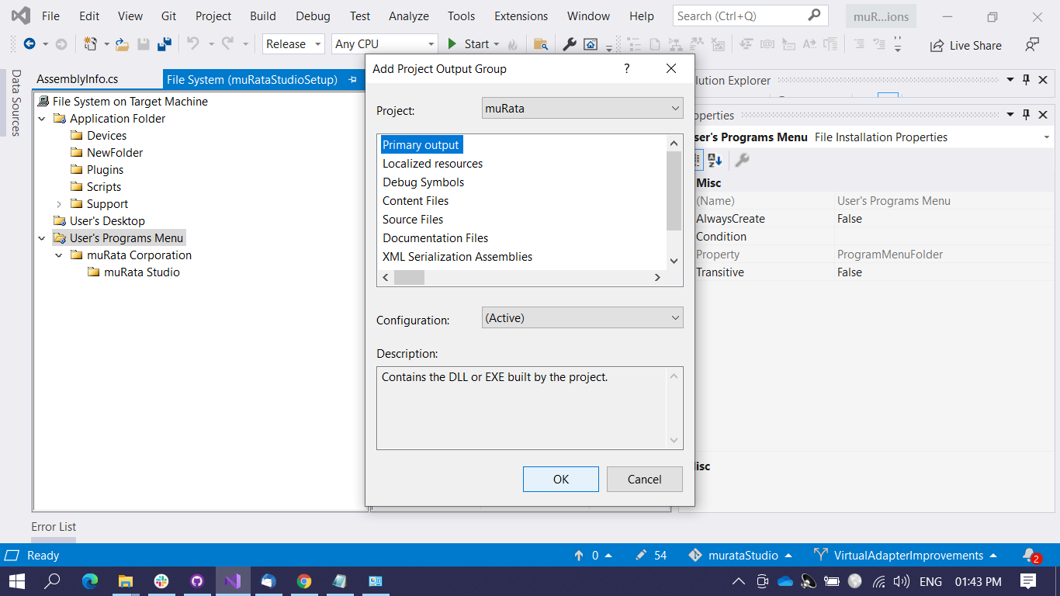

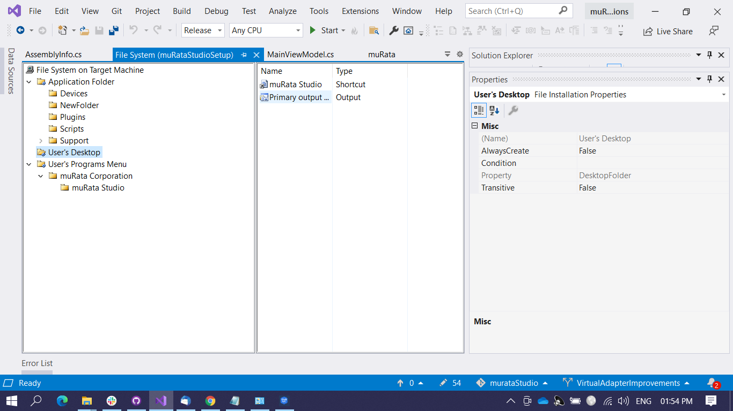

13) This steps above will update the File System Application folder with updated modifications on msi .

14) Now inorder to package the setup, we have to update the product code and version( need to be changed every time you build a new release. )

Select the muRataStudioSetup → Properties → Update the Version to next number by incrementing → Product code will be automatically updated once you update the Version. Last delivered version is 0.24.0, so next version to be delivered should be 0.25.0 (Instead of 1.0.4, type 0.25.0)

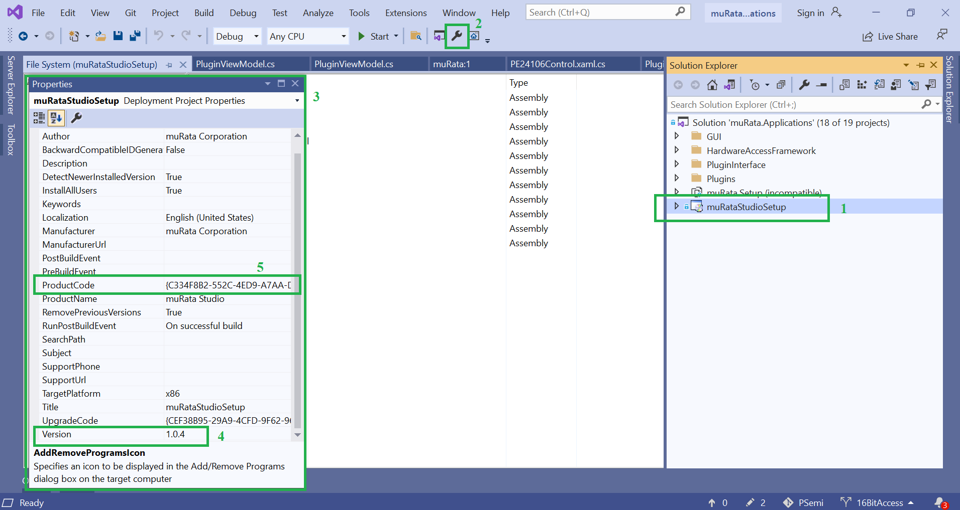

Additionally update the AssemblyInfo.cs file in VS Soltuon to match with the Version .For eg, if Version is 0.24.0, then AssemblyVersion should be 0.24.0.0 and similarly AssemblyFileVersion too

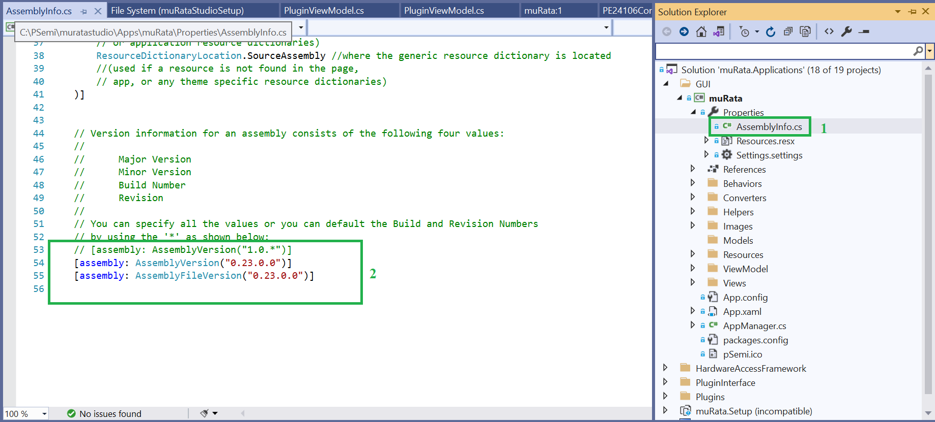Once the above changes are done save it and build the solution again in Release mode .

Once the build is successful, .msi/.exe can be located at

..\muratastudio\Solutions\muRata.Applications\muRataStudioSetup\Release.

Install the above .msi in our PC for internal testing and verify the application functionality.

If everything works as expected, Copy the .msi and .exe to a folder and zip it and share it in drop box for client access.

So, After we install the package we have to load application with different devices.

* We have to install the package and then we have to create a new shortcut and then browse to the location (i.e. "C:\Program Files (x86)\muRata Corporation\muRata Studio\muRataStudio.exe") and append the device which we have to load in demo mode.i.e.

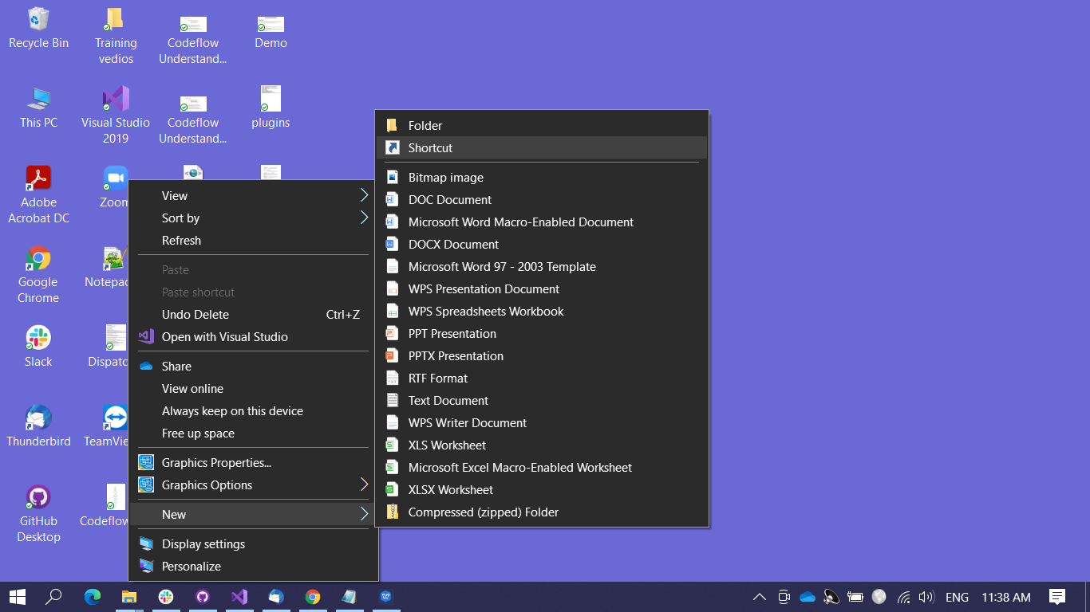"C:\Program Files (x86)\muRata Corporation\muRata Studio\muRataStudio.exe" /demo /d="ARC2CC06-R03"

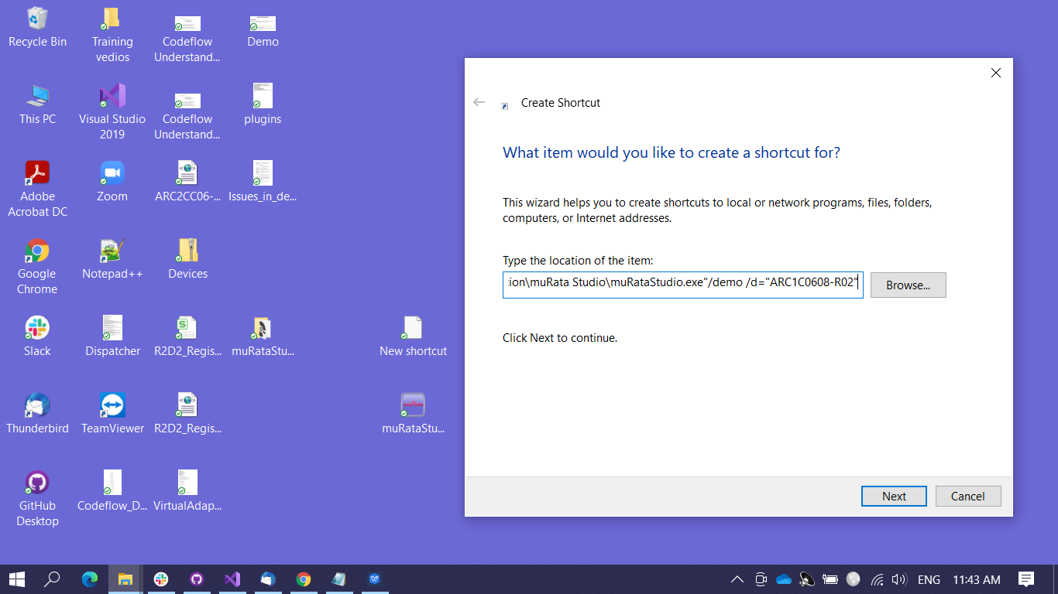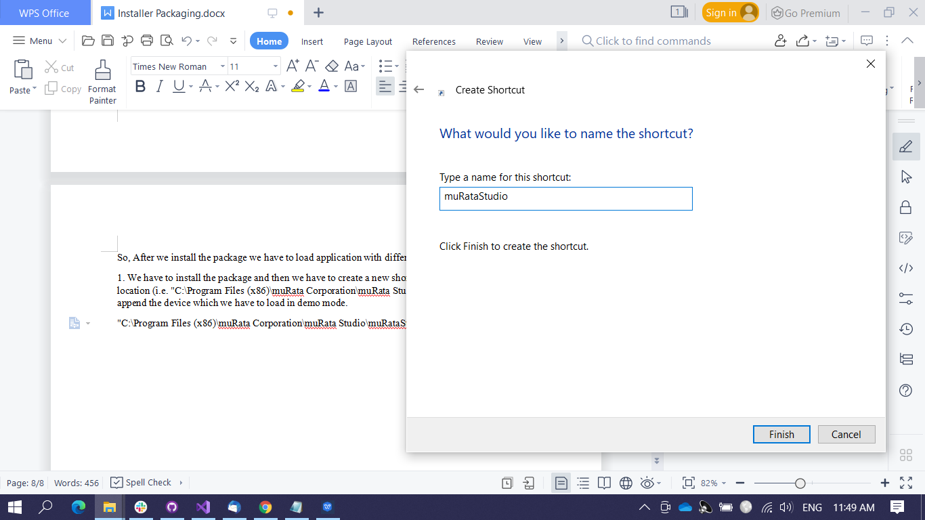

* So, Once we create the shortcut , we can launch the application.
* 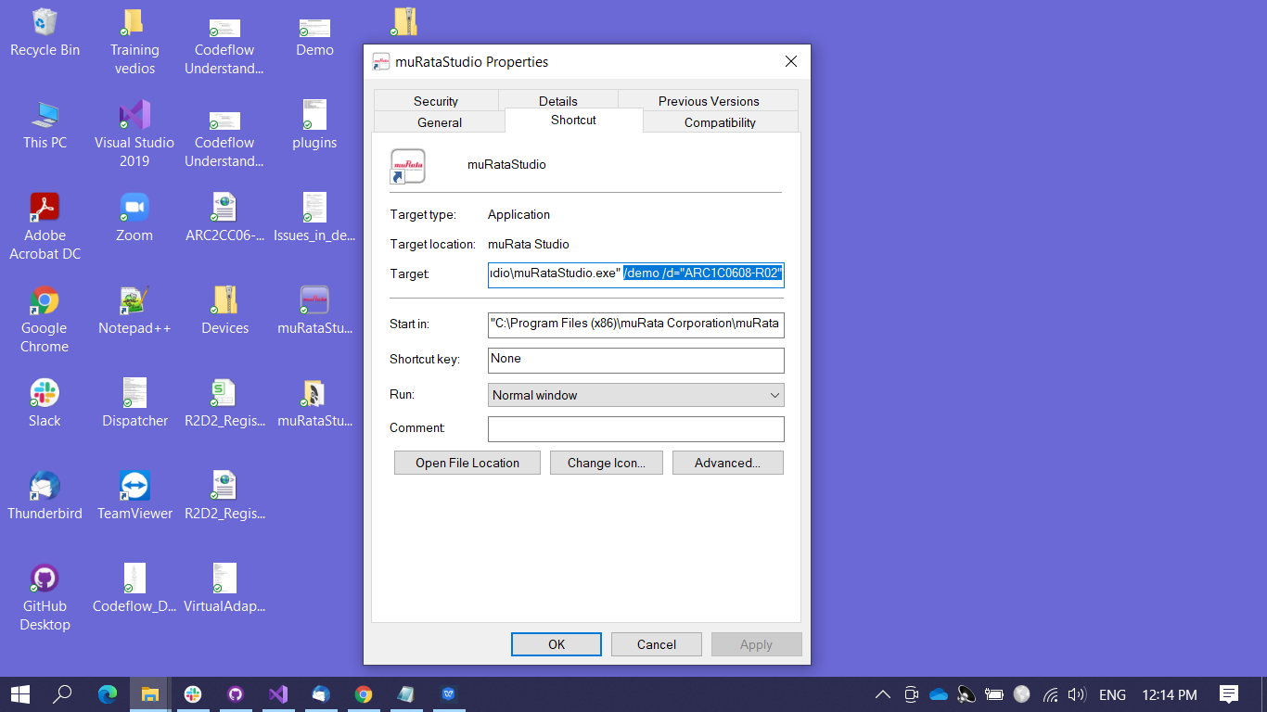If we have to load another device then, we can go o the properties of the application and append the device name to it as shown in below and then again launch the application we’ll be able to see that device is loaded.